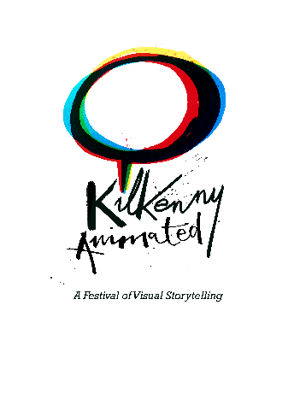

**28th August 2025 - Kilkenny, Ireland**

*For immediate release*

**Kilkenny Animated Festival Announces Line-Up**

3rd-5th October 2025

This year’s Kilkenny Animated Festival will take place in Kilkenny City from October 3rd - 5th 2025. Headliners this year include K-Pop Demon Hunters directors, Maggie Kang & Chris Applehans; Bojack Horseman production designer and Long Story Short supervising producer, Lisa Hanawalt; & Academy Award winning writer/director, Brenda Chapman (Brave).

Hosted by five-time Oscar ®nominated animation studio, Cartoon Saloon, BAFTA-winning Lighthouse Studios, and Schweppe Curtis Nunn Events, Kilkenny Animated is a celebration of the creativity and craft of animation, set against the charming backdrop of medieval Kilkenny.

The main programme of events runs on Saturday 4th and Sunday 5th October in Kilkenny’s Ormonde Hotel and offers insights into the creative process with a stellar line-up, including Maggie Kang and Chris Applehans, who will discuss the making of Netflix smash hit, K-Pop Demon Hunters; Lisa Hanawalt, creator of Tuca & Bertie and production designer of Bojack Horseman, who will share insights on animating for adults and the recent Netflix release, Long Story Short, and; Academy Award winner for Brave, Brenda Chapman, who joins the programme to reflect on an incredible decades-spanning career.

Also joining the mainstage are Magic Light Pictures founders, Michael Rose & Martin Pope, who will share insights from over two decades of delivering much-loved stories, including The Gruffalo and The Snail & The Whale, to the screen. Meanwhile, director Kevin Lima will present the Disney documentary, Not Just A Goof, which follows a young Lima and his creative team on the emotional rollercoaster of tackling their first Disney feature, its initial disappointment and its surprising resurgence decades later.

Artists and creators, Delphine Coudray, Colm Dowling, Giovanna Ferrari, Alan Holly, Clíodhna Lyons & Paddy Lynch will join the mainstage for a range of panels and talks focusing on different aspects of creative careers, including a spotlight on women first-time directors; a workshop on securing funding for creative projects; and the challenges of building a creative practice away from the studio environment. All mainstage events taking place in the Ormonde Hotel on Saturday Sunday can be accessed through a mainstage pass – now available.

Kilkenny Animated will be hosting plenty of events outside of the main programme so that animation-enthusiasts young and old can join in the experience. This includes creative workshops, screenings and sketching tours for which individual tickets are now available. Meanwhile, the Pathways to Animation educational programme for 2nd and 3rd level students returns for its third year.

Artists from Cartoon Saloon and Lighthouse Studios will lead sketching tours for 12+, offering an exploration of the medieval streetscapes of Kilkenny which inspired Cartoon Saloon’s WolfWalkers, or a biodiversity trail along the banks of the river Nore accompanied by marine biologist Tasneem Khan.

Kilkenny Animated is core funded by Fáilte Ireland and Kilkenny County Council and supported by Coimisiún na Meán.

Speaking about their support of Kilkenny Animated, Ciara Sugrue, Head of Festivals and Events at Fáilte Ireland, said: “Festivals and events present an excellent opportunity to showcase the rich heritage and unique culture that Ireland has to offer. They are also important drivers of tourism revenue across the country, particularly in areas that are outside of the traditional tourism hotspots. Developing unique and immersive visitor experiences like Kilkenny Animated plays a key role in motivating both international and domestic visitors to choose a destination, while helping drive the sustainable development of the tourism sector for the county and the wider region.”

Event sponsors include Animation Ireland, Screen Ireland, RTÉ and TG4, with workshops sponsored by Brophy Gillespie, SETU and Gorilla Post Production.

For more information on tickets, or to purchase a festival pass visit kilkennyanimated.com.

____________

Media Contacts

Sarah Maher, Communications Manager - sarah.maher@lighthousestudios.ie

Aoife O'Brien, Digital Marketing Manager - aoife.obrien@cartoonsaloon.ie

Festival Contact

Niamh Herrity, Festival Producer - producer@kilkennyanimated.com

